

BOOKLET 4b

Mathematics Methods 3&4

GRAPHS OF DERIVATIVE FUNCTIONS:

2018

B: GRAPHS OF DERIVATIVE FUNCTIONS:
- Sign of the gradient – Positive if the part of the graph is rising from left to right

- Negative gradient if it is descending from left to right.

- At turning point or point of inflection the gradient = 0 i.e at turning point or point of infection

- Horizontal line has gradient of zero.

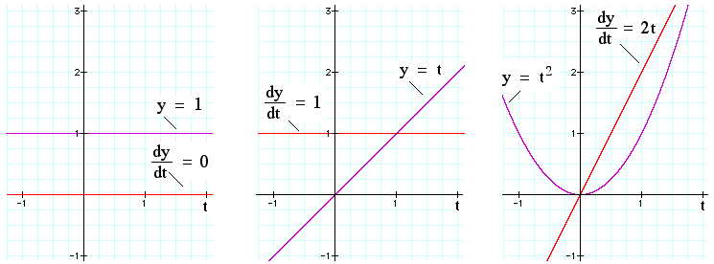

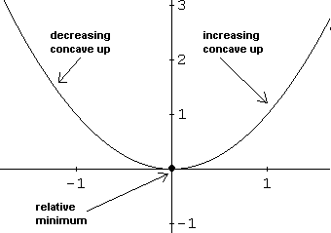

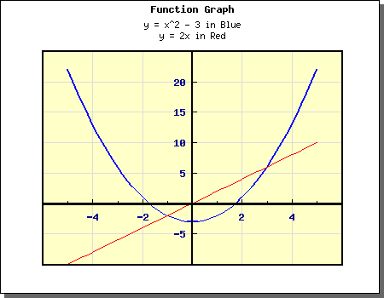

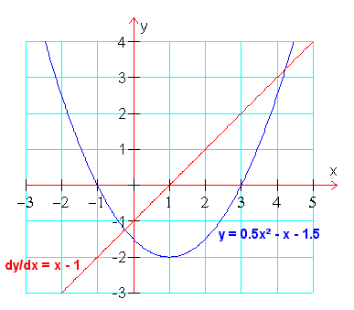

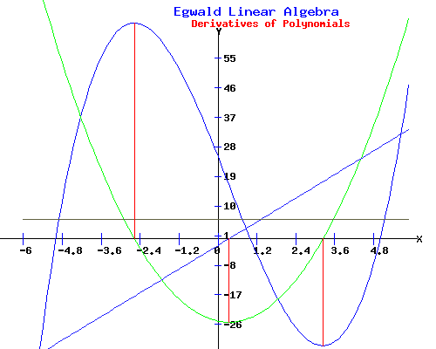

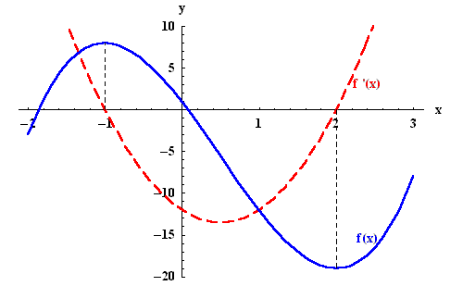

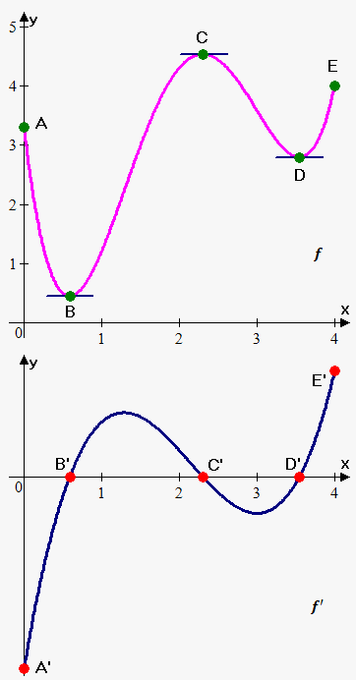

Summary
- A turning point on occurs when, . This is at a point when the curve is horizontal.

- A point of inflection on corresponds to a turning point on the and a horizontal intercept on

- A horizontal intercept on corresponds to either a turning point or a horizontal inflection point on

- A turning point on corresponds to an inflection point on. A turning point which is also a horizontal intercept is also a horizontal intercept on corresponds to a horizontal inflection point on

EXAMPLE:

The following diagram is for the function. Determine the x – coordinates of the turning point(s0 and inflection point(s) of

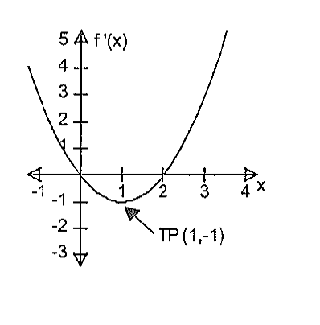

Solution:

intersects the x – axis at x = 0 and x = 2. Hence has turning points at

x = 0 and x = 2.

has a turning point at x = 1. Hence has an inflection point at x = 1.

EXERCISE 2:

Question One.

Given the sketch of , determine the x – coordinates of the turning point(s) and inflection point(s) of

(a) (b)

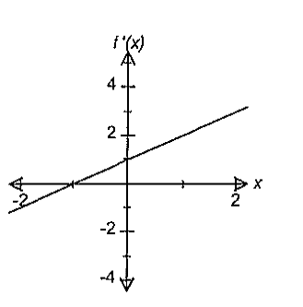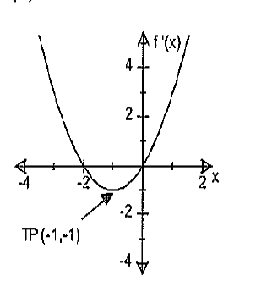

(c) (d)

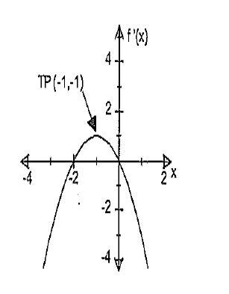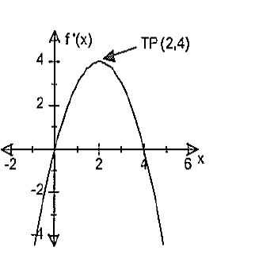

(e) (f)

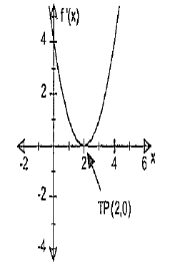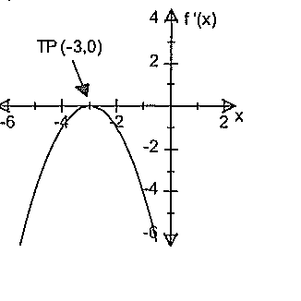

(g) (h)

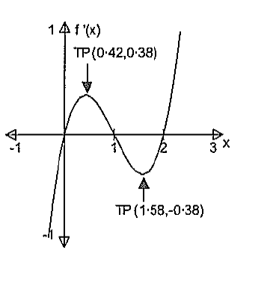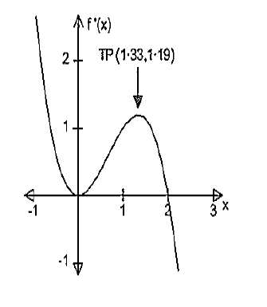

Question Two

Given the sketch of , determine the x – coordinate of point(s) of inflection of where it/they exist(s)

(a) (b)

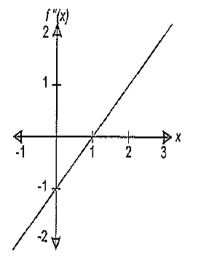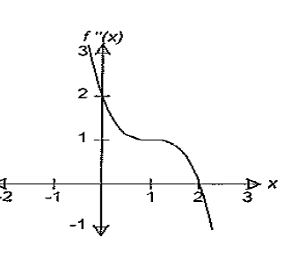

(c) (d)

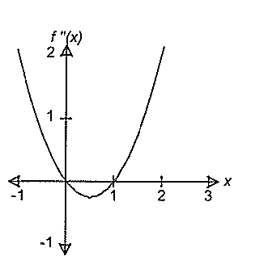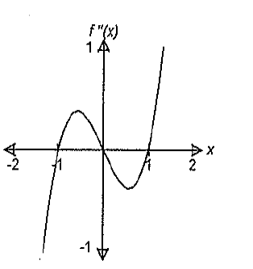

(e)

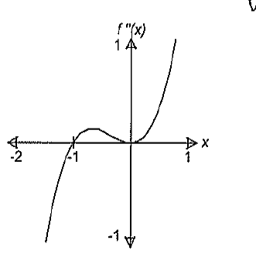

CURVE SKETCHING WITH DERIVATIVES:

Important features to note when drawing graphs of derivative functions
- y intercept is when x is equal to zero. i.e
- x – intercept is when y is equal to zero
- Sign of the gradient – Positive if the part of the graph is rising from left to right

- Negative gradient if it is descending from left to right.

- At a point of inflection the second derivative is and gradient = 0 i.e at turning point or point of infection

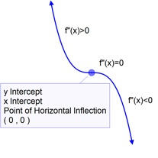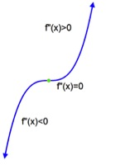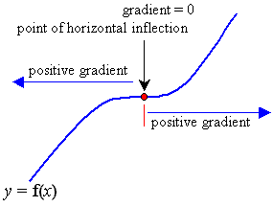

- At the turning point the gradient is zero

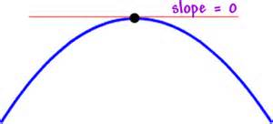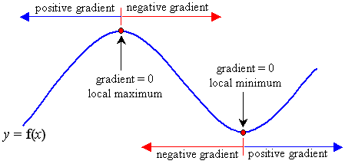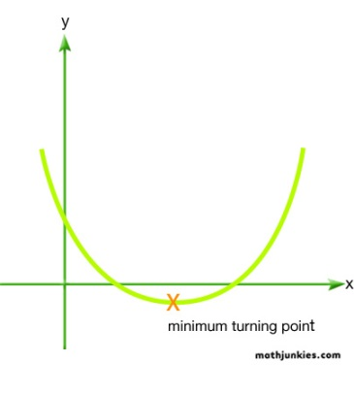

- If second derivative is zero, then we have a point of inflection i.e
- If second derivative is greater than zero, then the original graph graph us concave up i.e minimum i.e

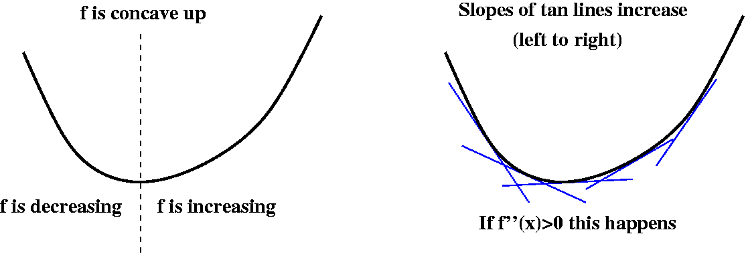

- If the second derivative is less than zero then the original graph is concave down i.e i.e maximum

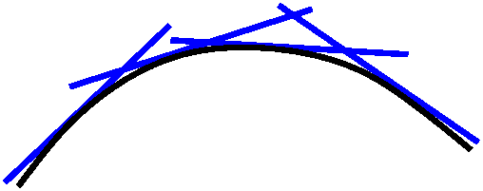

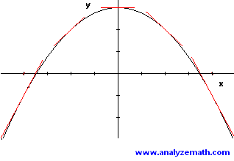

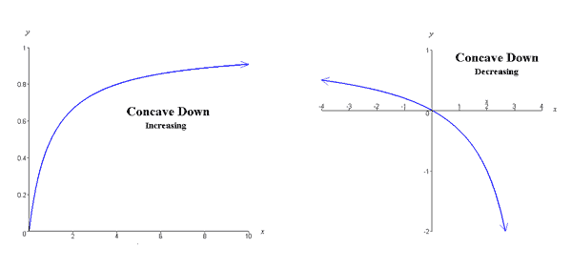

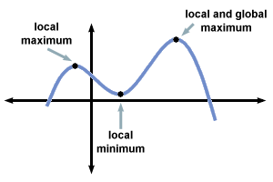

EXAMPLE

Given the sketch of , sketch a possible graph of

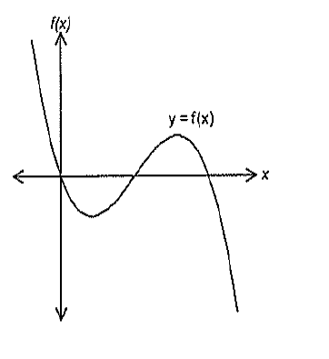

Solution:

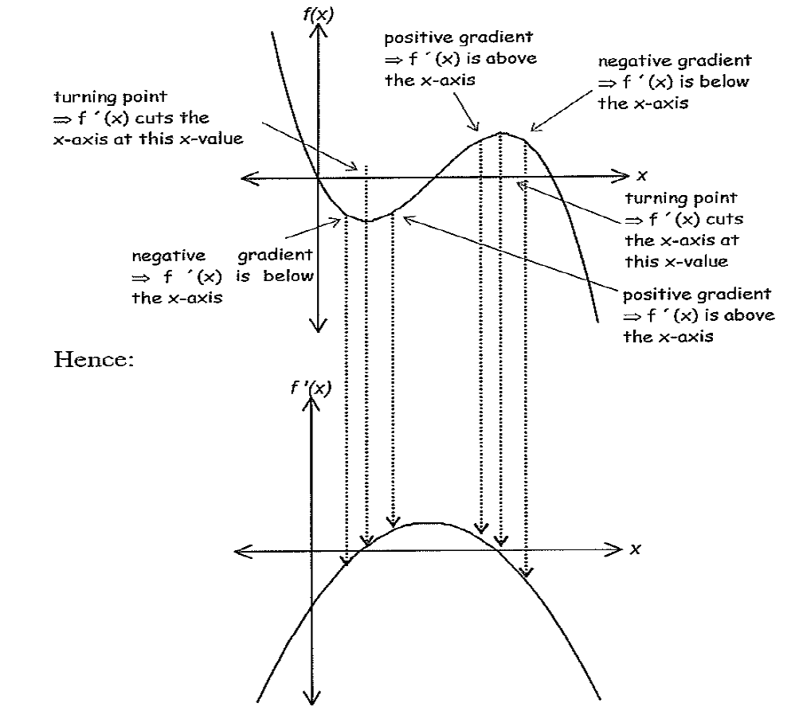

EXAMPLE

Given the sketch of , sketch a possible graph of

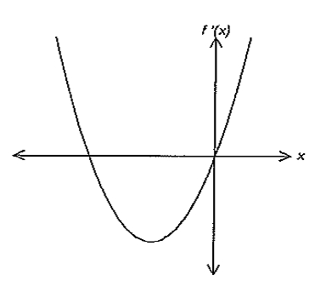

Solution:

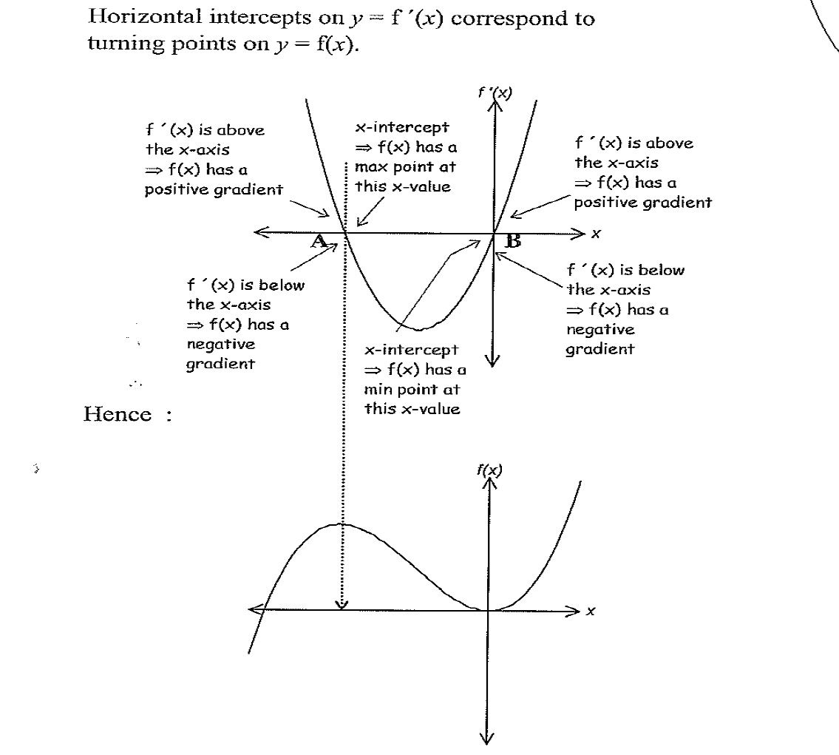

Question Three:

Given the sketch of , sketch a possible graph of

(a) (b)

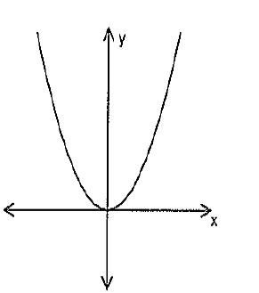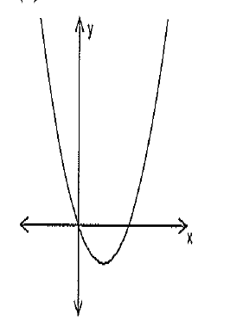

(c) (d)

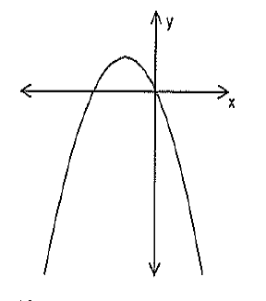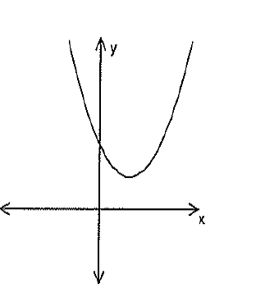

(e) (f)

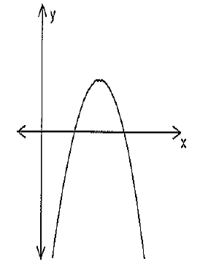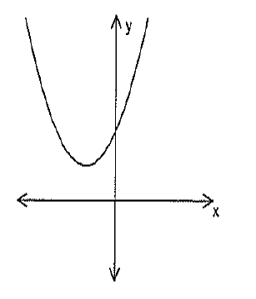

(g) (h)

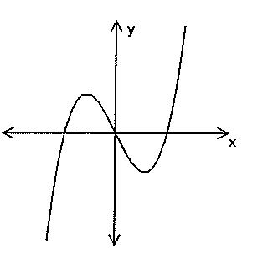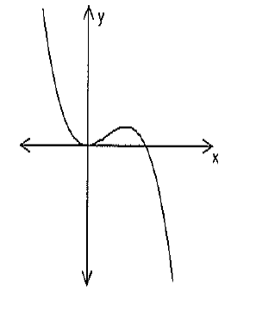

(i)

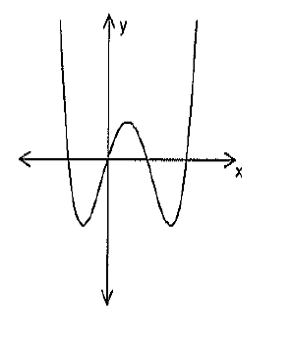
Question Four

Given the sketch of , sketch a possible graph of

